**Pattern Assignment 1**

**P1:** Write a program to draw a pattern given below from 0-100.

E.g. if n==5

*****

*****

*****

*****

*****

var star="";

var n=2;

for(i=0;i<n;i++)

{

for(j=0;j<n;j++)

{

star += "*";

}

star+="\n";

}

console.log(star);

**OUTPUT:-**

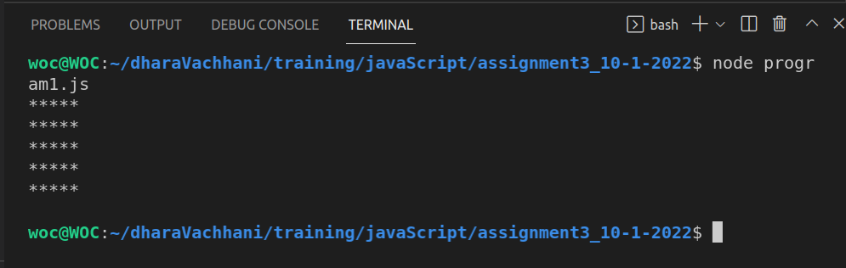

**P2:** Write a program to draw a pattern given below from 0-9.

E.g. if n==5

12345

12345

12345

12345

12345

var star="";

var n=2;

for(i=1;i<=n;i++)

{

for(j=1;j<=n;j++)

{

star += j;

}

star+="\n";

}

console.log(star);

**OUTPUT:-**

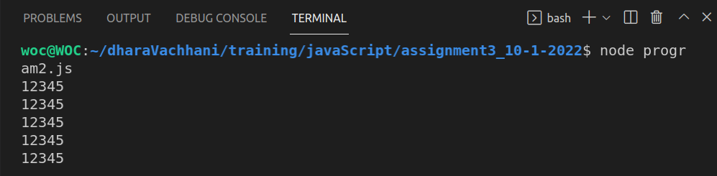

**P3:** Write a program to draw a pattern given below from 0-9.

E.g. if n==5

11111

22222

33333

44444

55555

var star="";

var n=2;

for(i=1;i<=n;i++)

{

for(j=1;j<=n;j++)

{

star += i;

}

star+="\n";

}

console.log(star);

**OUTPUT:-**

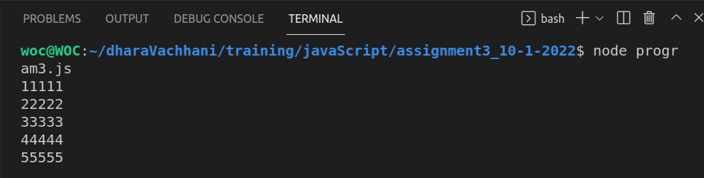

**P4:** Write a program to draw a pattern given below from 0-9.

E.g. if n==5

*

**

***

****

*****

var star="";

var n=7;

for(i=1;i<=n;i++)

{

for(j=1;j<=i;j++)

{

star += "*";

}

star+="\n";

}

console.log(star);

**OUTPUT:-**

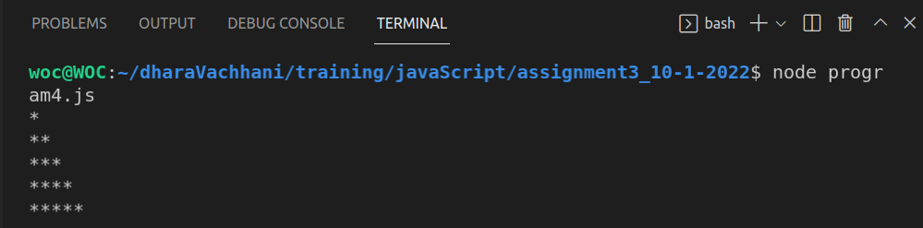

**5:** Write a program to draw a pattern given below from 0-9.

E.g. if n==5

*

**

***

****

*****

var star="";

var n=4;

for(i=0;i<=n-1;i++)

{

for(j=0;j<=n-1;j++)

{

if(i+j<n-1)

{

console.log(i,j,i+j);//

star+=" ";

}

else

{

star+="*";

}

}

star+="\n";

}

console.log(star);

**OUTOUT:-**

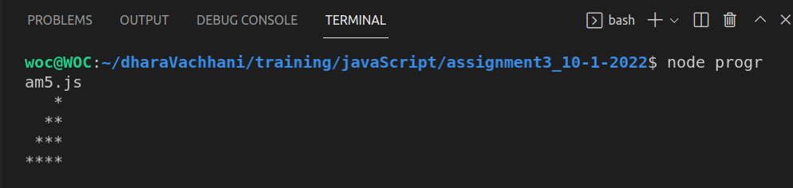

**P6:** Write a program to draw a pattern given below from 0-9.

E.g. if n==5

1

121

12321

1234321

123454321

var str="";

var n=5;

for(i=0;i<n;i++) // Rows - 5 times

{

for(j=-4;j<n;j++) // Columns - 9 times

{

if(i-Math.abs(j)>=0)

{

str+=i-Math.abs(j)+1;

}

else{

str+=" ";

}

}

str+="\n";

}

console.log(str);

OUTPUT:-

